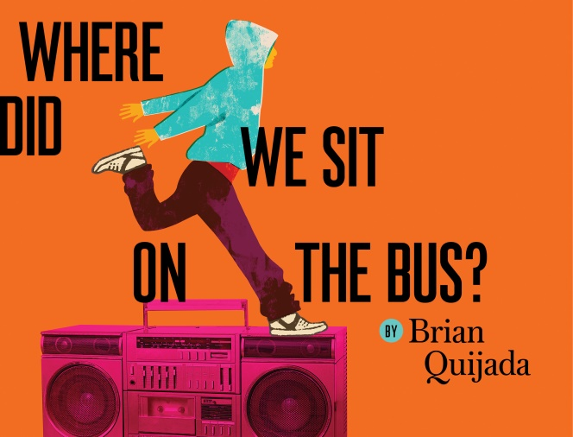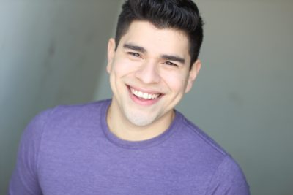

We are excited to share our dress rehearsal performance of City Theater’s production of Where Did We Sit on the Bus by Brian Quijada with community leaders from the Pittsburgh Metropolitan Area Hispanic Chamber of Commerce.
Dress rehearsal is our final performance run before we open the show to the public on Saturday. We have small invite only house of community partners attending and we greatly appreciate your being part of our first audience! The show is a hip-hop autobiography about falling in love with performance, the power of family, and growing up Latinx in a world that categorizes everyone in black and white.
The dress rehearsal is on Friday, January 18th at 7pm and will follow the community leaders meeting. Due to our theatre configuration there will be no late seating for the performance. The performance will run approximately 90 minutes and there will be an opportunity to meet Brian and director Chay Yew following the show.
City Theatre is located on the South Side at 1300 Bingham Street between 13th and 14th street. Parking is available in City’s lot located diagonally across the street from the theatre for $9; street parking is also available. You can find further information regarding the parking here.
City Theatre’s bar will be open during the meeting and prior to the performance to purchase beverages.
We look forward to sharing this sneak peek of the production with you and thank you for your partnership with City!

